**EfficientML.ai Project Ideas**

Contact: efficientml-staff@mit.edu≠

Feel free to select from the below projects, or propose your own projects. Team: 4-5 students.

**Project 1: TSM for Efficient Video Understanding**

The explosive growth in video streaming gives rise to challenges on performing video understanding at high accuracy and low computation cost. Conventional 2D CNNs are computationally cheap but cannot capture temporal relationships; 3D CNN based methods can achieve good performance but are computationally intensive, making it expensive to deploy. Temporal Shift Module (TSM) is a method that enjoys both high efficiency and high performance. TSM shifts part of the channels along the temporal dimension; thus facilitating information exchanged among neighboring frames. It can be inserted into 2D CNNs to achieve temporal modeling at zero computation and zero parameters. It can also run in an online manner for processing streaming videos. A demo is to use TSM for hand gesture recognition as shown below.

A few potential project ideas to extend TSM online demo:

* The online demo is based on MobileNetV2 backbone. It would be interesting to see how changing backbones affect the accuracy of the model.
* The demo model is trained on the Jester dataset. Feel free to try out other video datasets/tasks for your project (e.g., fall detection in healthcare).



**Project 2: GAN Compression**

Conditional Generative Adversarial Networks (cGANs) have enabled controllable image synthesis for many computer vision and graphics applications. However, recent cGANs are 1-2 orders of magnitude more computationally-intensive than modern recognition CNNs. For example, GauGAN consumes 281G MACs per image, compared to 0.44G MACs for MobileNet-v3, making it difficult for interactive deployment. GAN Compression is a general framework to compress conditional GANs. To stabilize the GAN training, it first transfers knowledge of multiple intermediate representations of the original model to its compressed model, and unify unpaired and paired learning. Second, instead of reusing existing CNN designs, it automatically finds efficient architectures via neural architecture search (NAS). To accelerate the search process, it decouples the model training and architecture search via weight sharing. Experiments demonstrate the effectiveness of it across different supervision settings (paired and unpaired), model architectures, and learning methods (e.g., pix2pix, GauGAN, CycleGAN). It reduces the computation of CycleGAN by more than 20× and GauGAN by 9×, paving the way for interactive image synthesis.

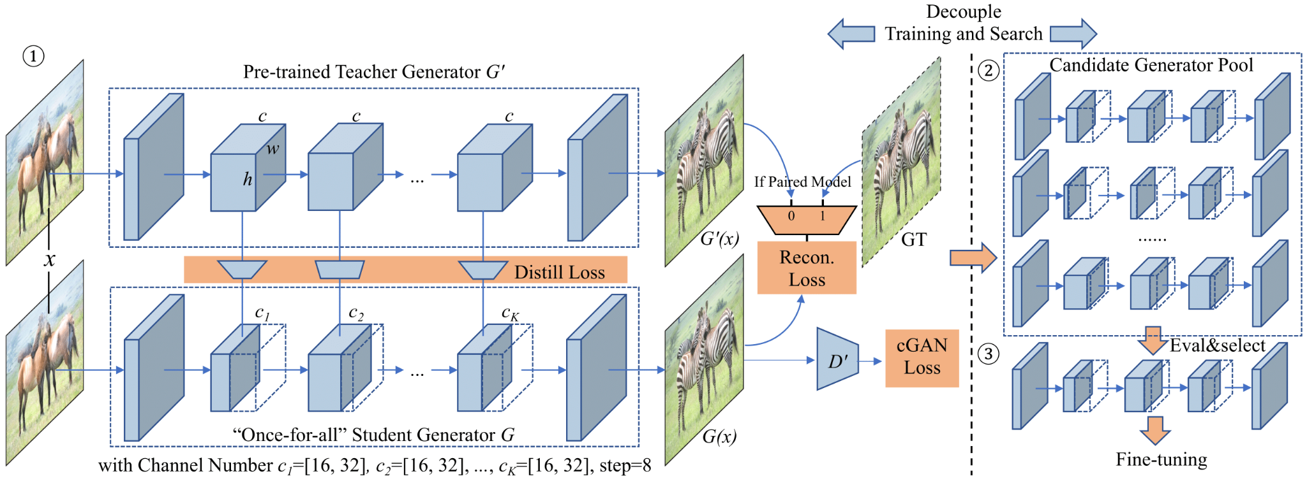

A potential project idea would be to deploy GAN Compression edge2shoes models on Raspberry Pi, measure the speedup and try to build an interactive demo.

* Procedure:
  + Download the pretrained PyTorch models.
  + Set up the environment (PyTorch and TVM) on Raspberry Pi.
  + Optimize the compressed model and measure the speedup.
  + Build an interactive UI (either use PyQT5 or use gradio).
  + Deliver the final demo.

**Project 3: SIGE**

During image editing, existing deep generative models tend to re-synthesize the entire output from scratch, including the unedited regions. This leads to a significant waste of computation, especially for minor editing operations. SIGE is such a sparse engine that accelerates image editing by caching and reusing the feature maps of the original image to generate only the edited regions.



A potential project idea would be to integrate SIGE with the latest Stable Diffusion XL (SDXL) and assess the performance enhancement. While SIGE is compatible with Stable Diffusion 1.4, the SDXL boasts fewer stages but incorporates a greater number of attention blocks and computational capacity. It's anticipated that with SDXL, SIGE might achieve even more significant speed improvements.

* Procedure:
  + Replace Stable Diffusion 1.4 model description with SDXL description.
  + Adapt diffusion SDXL model to SIGE codebase.
  + Replace the corresponding SDXL module with SIGE wrapped module.
  + Measure the corresponding speedup with SIGE’s examples.

**Project 4: On-device training**

On-device training enables the model to adapt to new data collected from the sensors by fine-tuning a pre-trained model. Users can benefit from customized AI models without having to transfer the data to the cloud, protecting the privacy. However, the training memory consumption is prohibitive for IoT devices that have tiny memory resources. Our recent project presents an algorithm-system co-design framework to make on-device training possible with only 256KB of memory. Please find the details here: <https://github.com/mit-han-lab/tiny-training>. We also include a demo below.

A potential project:

* Find the code base in the GitHub link above, and trying deploying it on a microcontroller (you may borrow one from the lab)
* Record a video on on-device training.



**Project 5: MCUNet**

Machine learning on tiny IoT devices based on microcontroller units (MCU) is appealing but challenging: the memory of microcontrollers is 2-3 orders of magnitude smaller even than mobile phones. We propose MCUNet, a framework that jointly designs the efficient neural architecture (TinyNAS) and the lightweight inference engine (TinyEngine), enabling ImageNet-scale inference on microcontrollers. With MCUNetV2, we are able to support object detection on commercial microcontrollers. Please find the demo below.

A potential project:

* Find the tiny detection model here: https://github.com/mit-han-lab/mcunet#detection-model
* Try deploying the model on MCUs to replicate the demo (you may borrow one from the lab)



**Project 6: Efficient Segment Anything (EfficientViT)**

Contact: Zhuoyang Zhang (zy_zhang@mit.edu)

SAM is a promptable segmentation system with zero-shot generalization to unfamiliar objects and images, without the need for additional training.

Related codebase: <https://github.com/mit-han-lab/efficientvit>



Potential Projects:

1. Apply EfficientViT-SAM to medical image segmentation.

2. Build real-world applications using the EfficientViT-SAM models.

**Project 7: FastComposer (Tuning-Free Multi-Subject Image Generation with Localized Attention)**

Contact: Guangxuan Xiao ([xgx@mit.edu](mailto:xgx@mit.edu))

Diffusion models excel at text-to-image generation, especially in subject-driven generation for personalized images. However, existing methods are inefficient due to the subject-specific fine-tuning, which is computationally intensive and hampers efficient deployment. Moreover, existing methods struggle with multi-subject generation as they often blend features among subjects. We present FastComposer which enables efficient, personalized, multi-subject text-to-image generation without fine-tuning. FastComposer uses subject embeddings extracted by an image encoder to augment the generic text conditioning in diffusion models, enabling personalized image generation based on subject images and textual instructions with only forward passes.

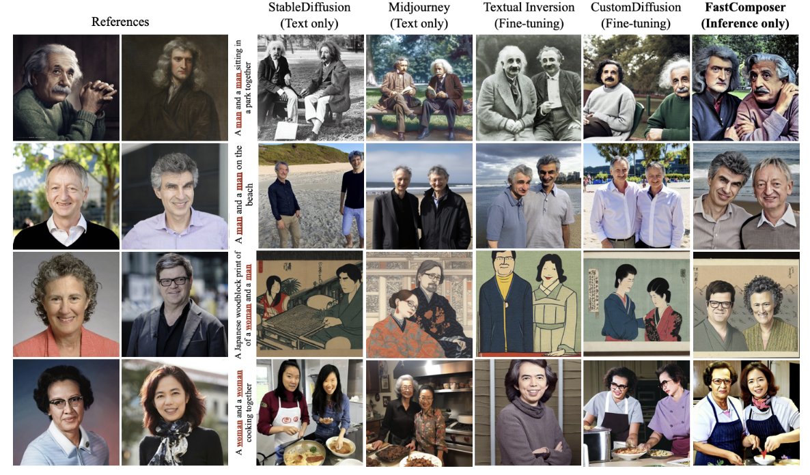

A few potential project ideas to extend FastComposer:

* While FastComposer excels at generating subject-specific images based solely on textual instructions, this method doesn't offer optimal control. By integrating FastComposer with ControlNet, we can enhance the precision of the image generation process, allowing for more detailed and nuanced control over the creation of subject-specific images.

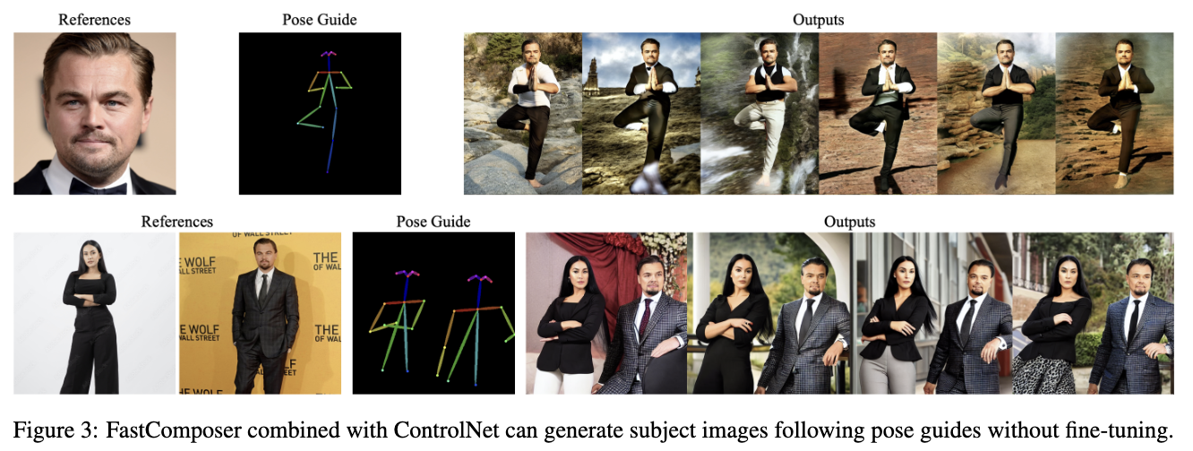

Demo: <https://fastcomposer.hanlab.ai/>

Related paper: <https://arxiv.org/pdf/2305.10431.pdf>

Related codebase: <https://github.com/mit-han-lab/fastcomposer>

**Project 8: Efficient Streaming Language Models with Attention Sinks (StreamingLLM)**

Contact: Guangxuan Xiao ([xgx@mit.edu](mailto:xgx@mit.edu))

Deploying Large Language Models (LLMs) in streaming applications such as multi-round dialogue, where long interactions are expected, is urgently needed. We develop StreamingLLM, an efficient framework that enables LLMs trained with a finite length attention window to generalize to infinite sequence lengths without any fine-tuning.

A few potential ideas to extend StreamingLLM:

* **Retrieval-Augmented StreamingLLM**: One of the limitations of StreamingLLM is its inability to attend to tokens that have been evicted, leading to a potential memory lapse of items outside the current attention window (<https://github.com/mit-han-lab/streaming-llm#faq>). An exciting extension would be the integration of StreamingLLM with the Retrieval-Augmented Generation (RAG) framework, such as LlamaIndex. This would allow the model to intelligently fetch evicted information back into the current context window. The outcome will be an LLM that not only produces infinitely coherent text but also retains access to past information and databases.

Potential Evaluation Strategies: Long document Question Answering (QA) or summarization (opt for either or explore both).

* **Persistent Daily Assitant:** Leveraging StreamingLLM, a logical application would be the creation of a continuous chatbot. How about developing a persistent daily assistant based on StreamingLLMs? This assistant could assist users with routine tasks, ranging from email management and analysis to weather updates and more.

Demo: [StreamingLLM Demo](https://youtu.be/UgDcZ3rvRPg?si=4ygMVRAp8xLCZIPn)

Related paper: <https://arxiv.org/abs/2309.17453>

Related codebase: <https://github.com/mit-han-lab/streaming-llm>

**Project 9: Exploration of Activation-aware Weight Quantization for LLM Compression and Acceleration (AWQ)**

Contact**: Haotian Tang (**[**kentang@mit.edu**](mailto:kentang@mit.edu)**), Shang Yang (shangy@mit.edu)**

AWQ has introduced an innovative method of weight quantization by identifying salient weights and preserving them for low-bit quantization. By doing this, AWQ achieves lossless accuracy with 4-bit weight-only quantization. However, what if we further explore lower-bit quantization for activations? Achieving a W4A4 (weight 4-bit, activation 4-bit) quantization could be highly valuable for LLM serving scenarios.

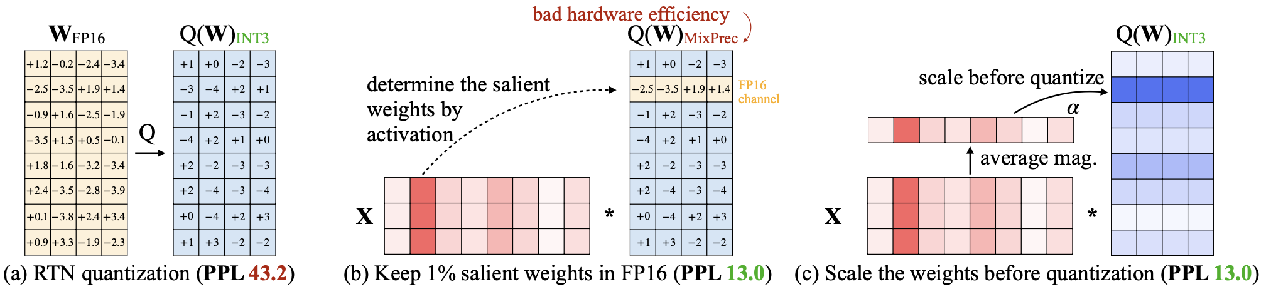

**Potential Project Ideas:**

1. W4A4 Quantization with Group Quantization:

* Goal:
  + Experiment with 4-bit group quantization for both weights and activations using the AWQ algorithm as a tuning mechanism.
* Procedure:
  + Implement W4A4 group quantization.
  + Test Llama models on the wikitext-2 dataset.
  + Use AWQ algorithm to tune the model.
  + Try to minimize the perplexity (ppl) such that the difference between the 4-bit quantized model and FP16 model is no more than 0.5.

1. Mixed-Precision Approach:

* Goal:
  + Explore mixed-precision quantization i.e. use FP16 to protect the salient weight channels and corresponding activation outliers, while the remaining values are quantized to 4-bit with per-channel(W)/per-token(A) quantization.
* Procedure:
  + Implement a mixed-precision approach as described.
  + Test OPT models on the wikitext-2 dataset.
  + As with the first idea, the goal is to keep the perplexity (ppl) difference between the mixed-precision model and FP16 model within 0.5.

**Expectations**:

At the end of this project, we should be able to comprehend the potential benefits and challenges of both W4A4 quantization and mixed-precision approaches. The outcomes of these experiments could provide valuable insights into the future of efficient and low-cost foundation model serving.

**Resources**:

You are recommended to thoroughly review the “SmoothQuant: Accurate and Efficient Post-Training Quantization for Large Language Models” and "AWQ: Activation-aware Weight Quantization for LLM Compression and Acceleration" paper for foundational understanding and as a base reference for the experiments.

Related codebase:   
 <https://github.com/mit-han-lab/llm-awq>  
 <https://github.com/mit-han-lab/smoothquant>

**Project 10: Sparse Attention**

(Token/Head pruning, progressive quantization)

SpAtten: [zhangzk@mit.edu](mailto:zhangzk@mit.edu) [hanrui@mit.edu](mailto:hanrui@mit.edu)

Attention is a critical component in modern large language models. General-purpose platforms such as CPUs and GPUs are inefficient when performing attention inference due to complicated data movement and low arithmetic intensity. Our profile shows attention can take >50% of latency in batched inference of LLM.

SpAtten is an efficient algorithm-architecture co-design that leverages token sparsity, head sparsity, and quantization opportunities to reduce the attention computation and memory access. Inspired by the high redundancy of human languages, SpAtten leverages cascade token pruning to prune away unimportant tokens in the sentence, and cascade head pruning to remove unessential heads. Cascade pruning is fundamentally different from weight pruning since there is no trainable weight in the attention mechanism, and the pruned tokens and heads are selected on the fly. SpAtten hardware consists of a specialized hardware pipeline to support attention operation, and utilizes a novel top-k engine to rank token and head importance scores with high throughput.

Potential Project:

Goal: optimize the performance or power/area efficiency SpAtten. Example ideas includes redesign the memory layout to improve bandwidth utilization, and reorganize the hardware pipeline to reduce stalls.

Procedure:

Understand the hardware design of SpAtten.

Run the simulation of SpAtten hardware, dump the waveform and analyze the performance bottleneck.

Implement your improved design in RTL code and compare the performance.

(Optionally) synthesize the hardware and compare the area/power efficiency.

Pre-requisties:

Basic digital circuit knowledge; experience of RTL (Verilog / Chisel / SpinalHDL) programming and simulation.

**Project 11: DuoAttention for Visual Language Model Acceleration**

Contact: Guangxuan Xiao ([xgx@mit.edu](mailto:xgx@mit.edu)), Jiaming Tang ([jmtang@mit.edu](mailto:jmtang@mit.edu))

Overview:  
Deploying large language models (LLMs) for long-context tasks faces significant computational and memory limitations, especially when dealing with the caching of Key and Value (KV) states across multiple attention heads. These challenges are even more critical in visual-language models, where the computational and memory demands are typically higher due to multimodal input processing.

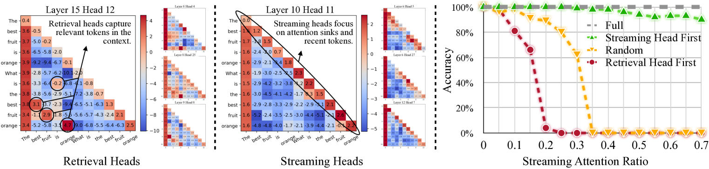

In this project, we will explore DuoAttention, a novel framework that reduces memory and computational overhead in LLMs by selectively applying full KV caching only to certain “Retrieval Heads,” which are crucial for processing long contexts. Other “Streaming Heads,” responsible for managing recent tokens and attention sinks, will employ a lightweight constant-length KV cache. This approach maintains long-context processing capabilities while improving memory efficiency and accelerating inference.

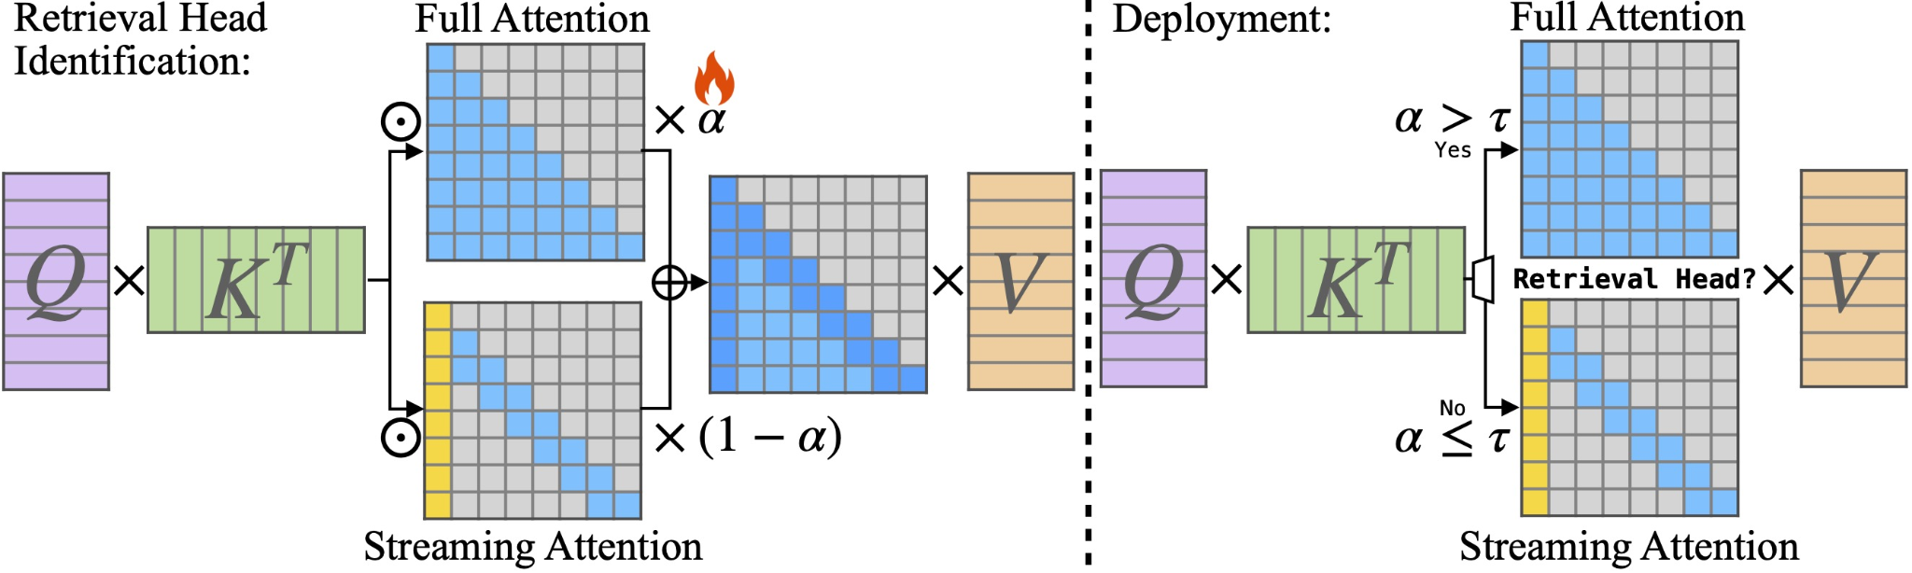

Our goal is to extend DuoAttention from language models to multimodal visual-language models (VLMs). Specifically, we aim to apply DuoAttention to a Visual Language Model such as LLaVa and VILA, optimizing the handling of long-context visual and text-based information. By doing so, we hope to significantly reduce the memory and latency overhead during inference without compromising performance.

Potential Applications:

1. Long-Context Visual Question Answering (VQA): Deploy DuoAttention-accelerated VLMs to handle multi-step VQA tasks where both long textual and visual contexts need to be processed efficiently
2. Video Question Answering (VideoQA): Apply DuoAttention to video question-answering tasks where both the visual context (spanning multiple frames or shots) and corresponding text need to be analyzed over long sequences. This allows the model to efficiently process long-duration videos while retaining key information from earlier scenes, enabling it to answer questions about events or objects introduced at different points in the video. DuoAttention will help reduce the memory and processing overhead of handling such long video contexts while maintaining high accuracy.

Demo: https://youtu.be/tyTkZOqKt6U

Related paper: https://arxiv.org/abs/2410.10819

Related codebase: https://github.com/mit-han-lab/duo-attention

**Project 12: Online Quantized Large Language Model Serving with QServe**

Contact: Haotian Tang([kentang@mit.edu](mailto:kentang@mit.edu)), Shang Yang ([shangy@mit.edu](mailto:shangy@mit.edu)), Yujun Lin ([yujunlin@mit.edu](mailto:yujunlin@mit.edu))

Overview:

Quantization can accelerate large language model (LLM) inference. Going beyond INT8 quantization, the research community is actively exploring even lower precision, such as INT4. Nonetheless, state-of-the-art INT4 quantization techniques only accelerate low-batch, edge LLM inference, failing to deliver performance gains in large-batch, cloud-based LLM serving. We uncover a critical issue: existing INT4 quantization methods suffer from significant runtime overhead (20-90%) when dequantizing either weights or partial sums on GPUs. To address this challenge, we introduce QoQ, a W4A8KV4 quantization algorithm with 4-bit weight, 8-bit activation, and 4-bit KV cache. QoQ stands for quattuor-octo-quattuor, which represents 4-8-4 in Latin. QoQ is implemented by the QServe inference library that achieves measured speedup. The key insight driving QServe is that the efficiency of LLM serving on GPUs is critically influenced by operations on low-throughput CUDA cores. Building upon this insight, in QoQ algorithm, we introduce progressive quantization that can allow low dequantization overhead in W4A8 GEMM. Additionally, we develop SmoothAttention to effectively mitigate the accuracy degradation incurred by 4-bit KV quantization. In the QServe system, we perform compute-aware weight reordering and take advantage of register-level parallelism to reduce dequantization latency. We also make fused attention memory-bound, harnessing the performance gain brought by KV4 quantization. As a result, QServe improves the maximum achievable serving throughput of Llama-3-8B by 1.2× on A100, 1.4× on L40S; and Qwen1.5-72B by 2.4× on A100, 3.5× on L40S, compared to TensorRT-LLM. Remarkably, QServe on L40S GPU can achieve even higher throughput than TensorRT-LLM on A100. Thus, QServe effectively reduces the dollar cost of LLM serving by 3×.

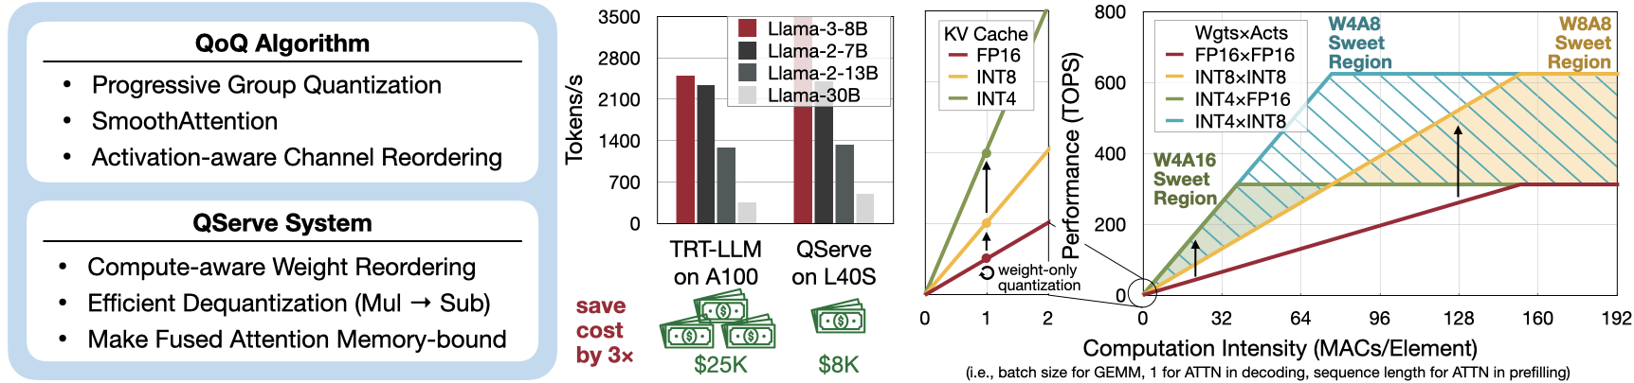

Paper: <https://arxiv.org/abs/2405.04532>

Code: <https://github.com/mit-han-lab/qserve>

Goal of this project: In our open source code, we implemented an offline batched generation system with QServe. In real-world applications, building online real-time serving systems is also very important. The target of this project is to utilize existing QServe frontend and backend functionalities and extend it to an online serving system. One may refer to vLLM and SGLang from UC Berkeley for more details. The final objective is to build an online Gradio demo that can serve QServe-quantized W4A8KV4 LLMs.

**Project 13: Deploy HART on Laptop**

Contact: Haotian Tang([kentang@mit.edu](mailto:kentang@mit.edu))

Overview: We introduce Hybrid Autoregressive Transformer (HART), an autoregressive (AR) visual generation model capable of directly generating 1024x1024 images, rivaling diffusion models in image generation quality. Existing AR models face limitations due to the poor image reconstruction quality of their discrete tokenizers and the prohibitive training costs associated with generating 1024px images. To address these challenges, we present the hybrid tokenizer, which decomposes the continuous latents from the autoencoder into two components: discrete tokens representing the big picture and continuous tokens representing the residual components that cannot be represented by the discrete tokens. The discrete component is modeled by a scalable-resolution discrete AR model, while the continuous component is learned with a lightweight residual diffusion module with only 37M parameters. Compared with the discrete-only VAR tokenizer, our hybrid approach improves reconstruction FID from 2.11 to 0.30 on MJHQ-30K, leading to a 31% generation FID improvement from 7.85 to 5.38. HART also outperforms state-of-the-art diffusion models in both FID and CLIP score, with 4.5-7.7x higher throughput and 6.9-13.4x lower MACs.

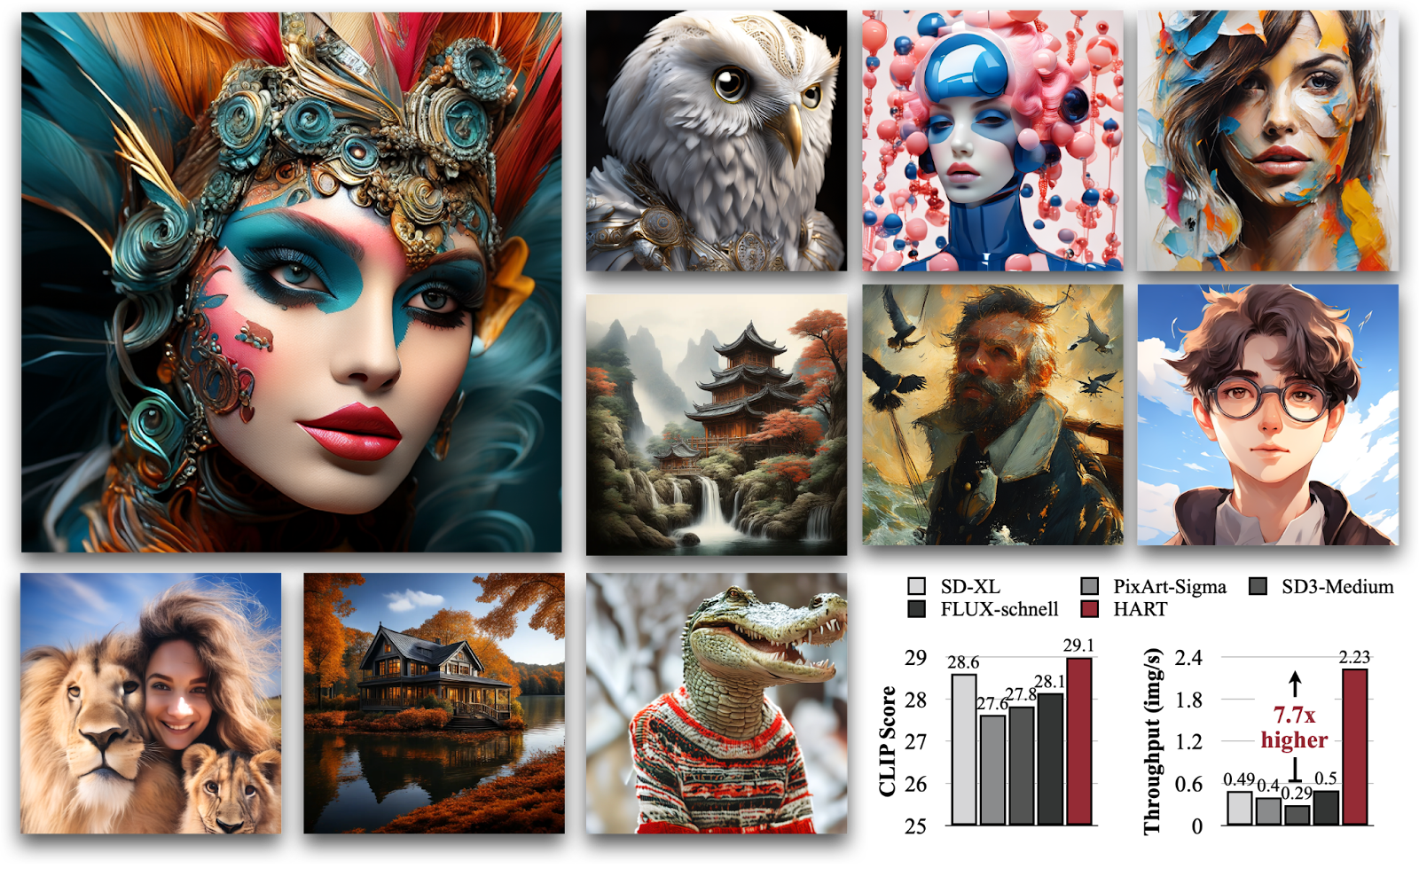

Demo: <https://hart.mit.edu>

Paper: <https://arxiv.org/abs/2410.10812>

Project: <https://hanlab.mit.edu/projects/hart>

GitHub: <https://github.com/mit-han-lab/hart>

Our goal is to deploy HART on Macbook. The provided open source implementation deploys HART on laptops with NVIDIA GPUs, but it has not supported model deployment on Macbook GPUs yet. The goal of this project is to deploy and optimize HART on Macbooks. The PyTorch MPS backend and Apple’s MLX framework can be great references for this project.

**Project 14: Applications with Visual Language Models (VILA)**

Contact: Haotian Tang([kentang@mit.edu](mailto:kentang@mit.edu))

Overview:

Visual language models (VLMs) rapidly progressed with the recent success of large language models. There have been growing efforts on visual instruction tuning to extend the LLM with visual inputs, but lacks an in-depth study of the visual language pre-training process, where the model learns to perform joint modeling on both modalities. In this work, we examine the design options for VLM pre-training by augmenting LLM towards VLM through step-by-step controllable comparisons. We introduce three main findings: (1) freezing LLMs during pre-training can achieve decent zero-shot performance, but lack in-context learning capability, which requires unfreezing the LLM; (2) interleaved pre-training data is beneficial whereas image-text pairs alone are not optimal; (3) re-blending text-only instruction data to image-text data during instruction fine-tuning not only remedies the degradation of text-only tasks, but also boosts VLM task accuracy. With an enhanced pre-training recipe we build VILA, a Visual Language model family that consistently outperforms the state-of-the-art models, e.g., LLaVA-1.5, across main benchmarks without bells and whistles. Multi-modal pre-training also helps unveil appealing properties of VILA, including multi-image reasoning, enhanced in-context learning, and better world knowledge.

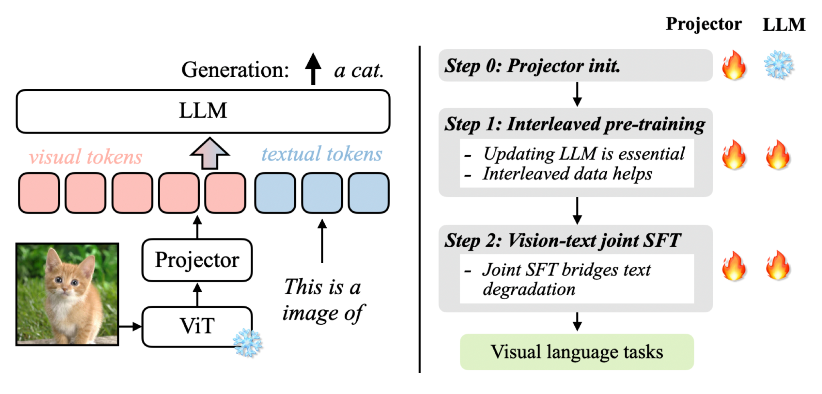

Demo: <https://vila.mit.edu>

Open source: <https://github.com/nvlabs/vila>

The goal of this project is to explore downstream applications of VILA. There are some directions we think might be interesting:

* VILA for robotics;
* VILA for autonomous driving;
* VILA for visual generation models: use VILA as a judge to improve the quality of visual generation;
* Voice chat with VILA;
* Improving VILA through post-training techniques such as chain-of-thought prompting.

You are welcomed to propose new ideas that either innovatively extend VILA’s impact to more domains, or improve VILA’s capability.